CS214 Final Project Design Document 1
Toby Zheng

ERD
Entities (with attributes) are displayed below. Relationships between entities are described using Crow’s Feet Notation.
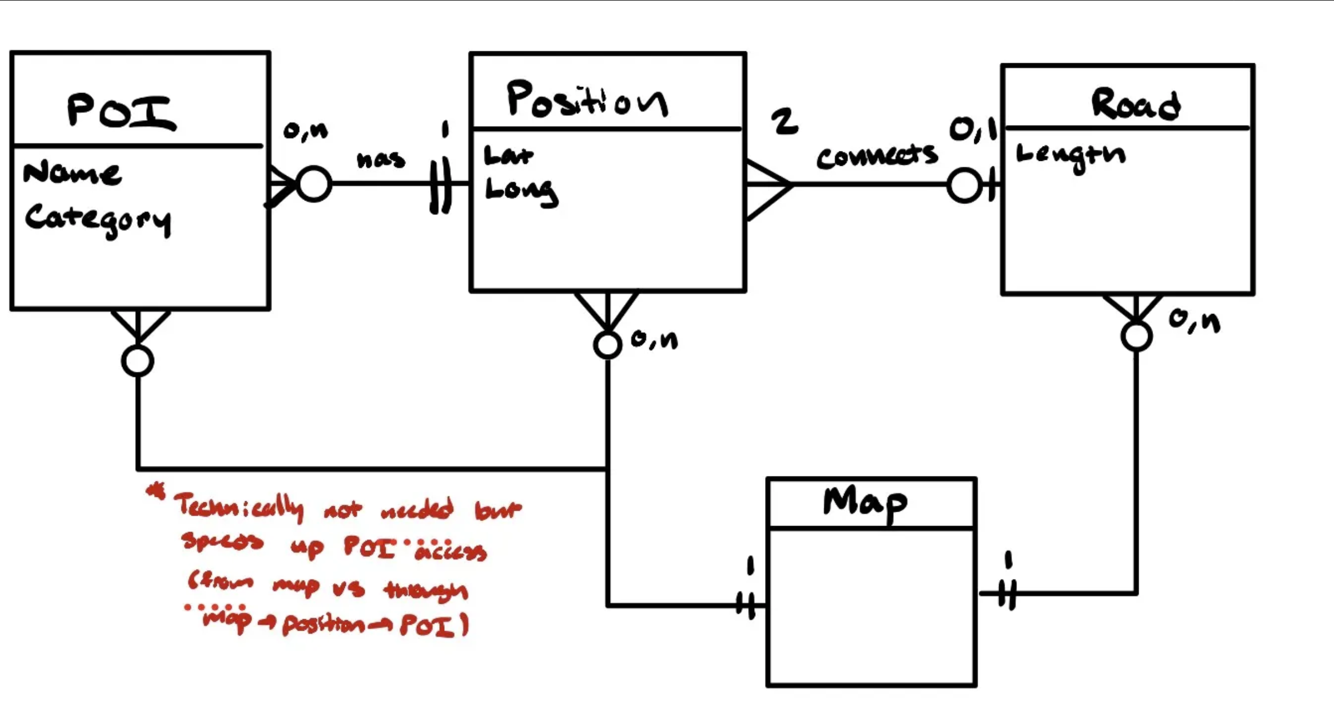

Building Blocks and ADTs

Entity Representation
Map: Weighted Undirected Graph (further described below). WU Graph because roads have a length and do not have an associated direction (two-way).
POI: Struct with name and category
Position: Struct with latitude, longitude (associated POIs described below)
Road: Struct with position1, position2, length

Data Structures
Collection of Roads: Represented in Map: edges in the WU graph are roads, the weights of edges correspond to length of roads
Collection of Positions: Represented in Map: each vertex of the WU graph will be a position. Needs a dictionary to map position coordinates (lat, long) to an integer (vertex). Use a second to map vertices to position coordinates as well.
Collection of POI(s) (by position): Take advantage of the graph representation of the Map (with integer vertices) to have direct access to POIs instead of top-down linear access through positions. Use a dictionary to map vertex to a set of POI structs at the associated position.

Additional data structures to optimize the three queries required:
Collection of POI(s) (by category): Use a dictionary to map a category to a set of POIs in the associated category.
Collection of POI Locations (by name): Use a dictionary to map a POI name to the position of a POI (i.e. the vertex on the graph representing the position).

